

**SOLUTION DEFINITION DOCUMENT**

Emplopad

**PAYROLL**

**TEEMWORX INFORMATION SYSTEMS AND CONSULTANCY, INC.,**

**REVISION HISTORY**

|  |  |  |  |  |  |
| --- | --- | --- | --- | --- | --- |
| **VERSION** | **DESCRIPTION** | **DATE** | **UPDATED SECTION(S)** | **UPDATE TYPE(S)** | **AUTHOR** |
| V1.0.0 | Initial | 10-Nov-2016 | All | All | C. Almario |
| V.1.0.1 | Initial Reviewed | 28-Dec-2016 | All | All | C. Almario |
| V.1.0.2 | Final Review | 15-Dec-2016 | All | All | C. Almario |
|  |  |  |  |  |  |

Table of Contents

1 Introduction 6

1.1 Purpose 6

1.2 Scope 6

1.3 Overview 6

2 System Overview 6

3 Standard System Features 7

3.1 Payroll Process Overview 7

3.2 Settings and Configurations 11

3.2.1 Payroll Periods 11

3.2.2 Partner Setup 14

3.2.3 Loans Entry 18

3.2.4 Timekeeping Summary 21

3.3 Listing and Applications 22

3.3.1 Recurring Entries 22

3.3.2 Batch Entries 24

3.3.3 Bonus 26

3.3.4 Payroll Transactions 28

3.4 Reports 31

3.4.1 Preliminary Report 31

3.4.2 Payroll Register 32

3.4.3 Payslip 35

3.4.4 Government Reports 36

4 Functional Requirements 51

4.1 Functional Requirements for Configuration 51

4.2 Functional Requirements for Customization 52

5 Conceptual Design for Customization 53

5.1 13th Month Pay 54

5.2 Custom Reports 56

5.2.1 Payroll Journal Register Report **Error! Bookmark not defined.**

5.2.2 Payroll Summary per Department 56

5.2.3 Letter of Instruction to the Bank 57

5.2.4 Bank Remittance Text file 58

5.2.5 Monthly Contributions (PAGIBIG) Report **Error! Bookmark not defined.**

5.2.6 Loan Contributions List (LCL) Report 58

5.2.7 Monthly Contributions List (MCL) Report 59

5.2.8 Monthly SSS Loan Contribution Report **Error! Bookmark not defined.**

5.2.9 Certificate of Credible Tax Withheld At Source (2307) Report 60

5.3 Compensatory Allowance Table 62

6 Signatories 70

**List of Figures**

Figure 1. Payroll process flow 9

Figure 2. List of payroll periods 11

Figure 3. Payroll Period details 12

Figure 4. List of employees' payroll setup 14

Figure 5. Employee Payroll Setup details 16

Figure 6. List of employee loans 18

Figure 7. Employee Loan details 19

Figure 8. List of timekeeping period summary 21

Figure 9. Recurring Entries details 23

Figure 10. List of batch entries 24

Figure 11. Batch Entries details 25

Figure 12. List of bonuses 26

Figure 13. Bonus details 26

Figure 14. List of current transactions 28

Figure 15. Current Transaction details 29

Figure 16. List of closed transactions 30

Figure 17. Preliminary Report 31

Figure 18. Preliminary Earnings Report 31

Figure 19. Preliminary Deduction Report 32

Figure 20. Payroll Register 32

Figure 21. Payroll Register Earnings Report 33

Figure 22. Payroll Register Deduction Report 34

Figure 23. Payslip 35

Figure 24. BIR 2316 36

Figure 25. SSS R-3 Monthly Premium Contribution 37

Figure 26. SSS R-3 Quarterly Contribution 38

Figure 27. SSS Remittance Certificate 39

Figure 28. HDMF Membership Registration/Remittance Form 40

Figure 29. HDMF Quarterly Membership Registration/Remittance Form 41

Figure 30. HDMF Short-Term Loan Remittance Form (STLRF) 42

Figure 31. HDMF Remittance Certificate 43

Figure 32. PhilHealth RF-1 Monthly Employer's Remittance Report 44

Figure 33. PhilHealth RF-1 Quarterly Employer's Remittance Report 45

Figure 34. PhilHealth Remittance Certificate 46

Figure 35. ATM Register Report 47

Figure 36. Non-ATM Register Report 47

Figure 37. Attendance Adjustment Report 48

Figure 38. Deduction Schedule Detail Report 49

Figure 39. Journal Voucher 50

Figure 40. 13th Month Pay details 54

Figure 41. 13th Month Pay Report 55

Figure 42. Early Retirement Pay Report 56

# Introduction

## Purpose

This purpose of this document is to provide outline functional specification and documentation for what shall be available to the user on Payroll module. This specification might change as the development proceeds. Will add more details and edit existing information as site architecture and use cases evolve in the course of the development.

## Scope

To provide the overview of the processes involving Payroll module and its requirements related to Human Resource Information System (HRIS).

## Overview

This document is organized in six sections. The first two parts namely, Introduction and System Overview sections provide a general description of the system’s functionality and design. The Standard System Features section that follows, offers the available features and existing reports in the system, along with its process overview. The next two sections are comprised of the client’s functional specifications and conceptual illustration of user interfaces in line with client requirements. Lastly, signatories of the document to represent both parties’ concurrence are added herein.

# System Overview

Emplopad (hereafter “the system”) is a Human Resource Information System that has complete HR tracking, management, evaluation and analysis tools, designed not just to boost HR processes but also engage workforce. Emplopad is comprised of core modules namely; Employee Management, Attendance Management and Payroll Module.

The Employee Management module manages all relevant employee information and offers a more efficient way of handling employee-related activities. This module allows viewing/updating of personal information such as: company information, contact information, emergency contact, ID Numbers, family background, education and employment history.

The Attendance Management system automatically computes for the total number of hours worked by employees for a certain cut-off period based on defined company policy and setup. It increases productivity, reduces costs and provides accurate managerial reports.

The Payroll System can be configured depending on the company’s payroll parameters. It handles loans monitoring and processing. It can also handle special payroll processing such as 13th month pay computation and other company-related bonuses.

# Standard System Features

## Payroll Process Overview







Figure 1. Payroll process flow



Figure 1.1. Payroll process flow

## Settings and Configurations

Comprise of modules for basic setup and configuration related to payroll processing.

### Payroll Periods

This is where payroll period covering specific inclusive dates are created. Payroll period should be closed upon completion of all transactions in order to generate pay slip and other payroll reports such as Payroll Register.

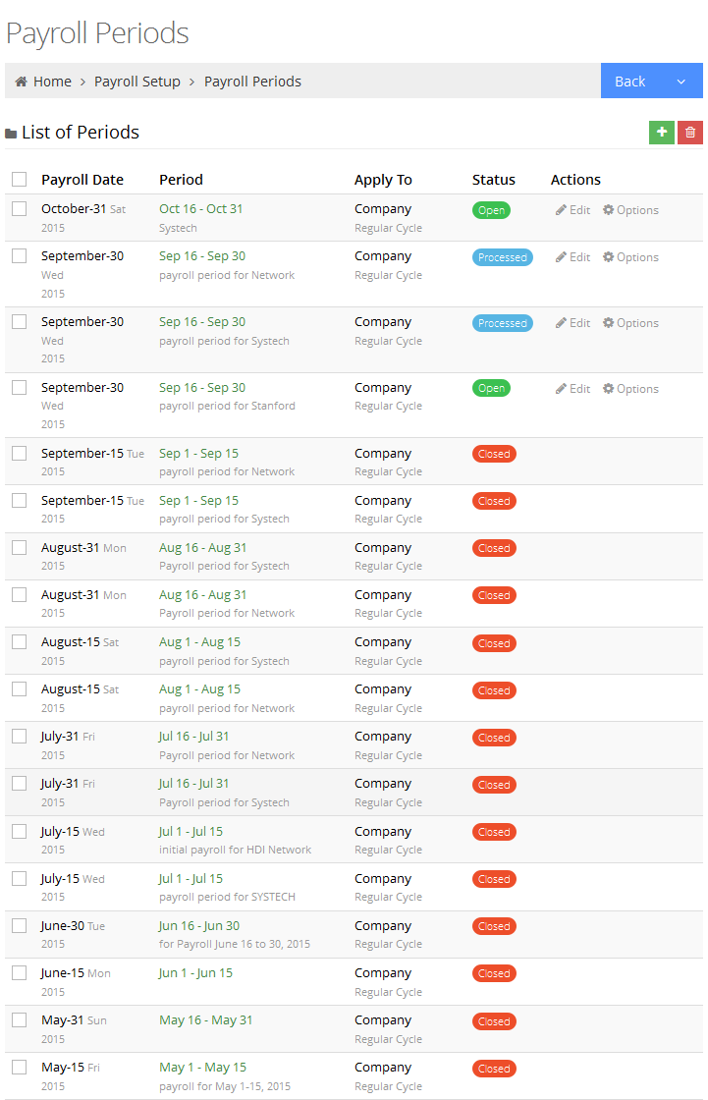

Figure 2. List of payroll periods

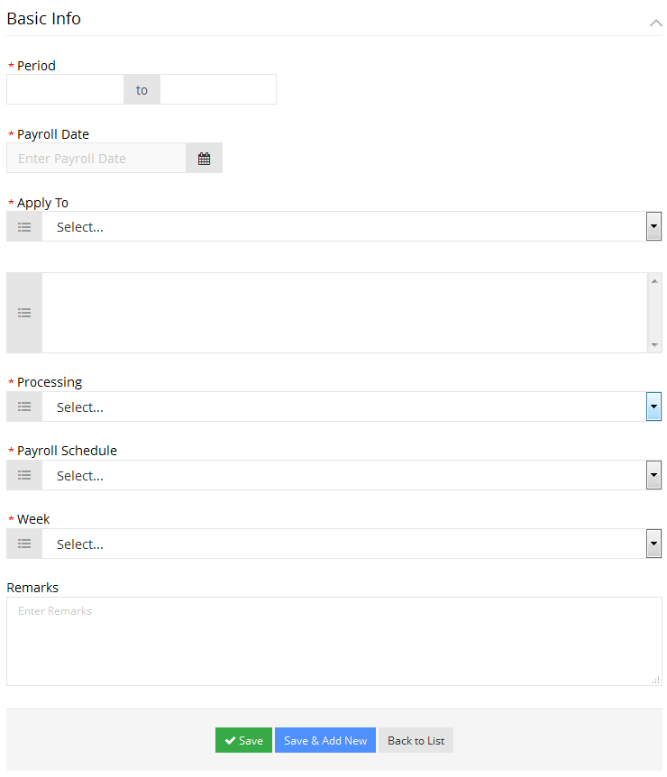

Figure 3. Payroll Period details

### Partner Setup

This is where details related to employees’ payroll is set up.

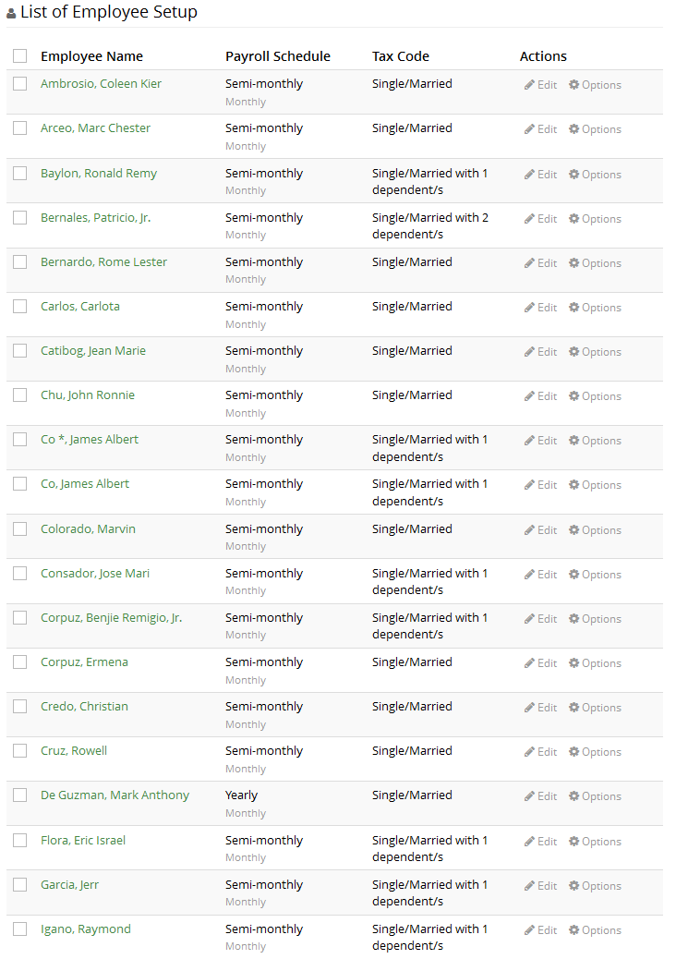

Figure 4. List of employees' payroll setup

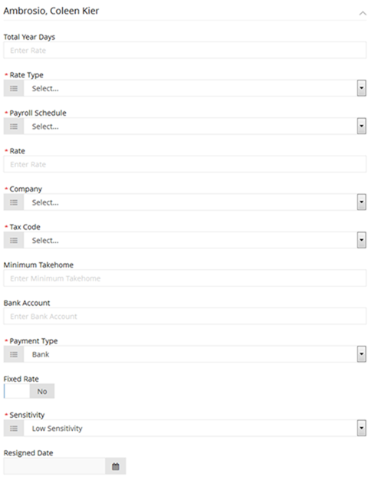

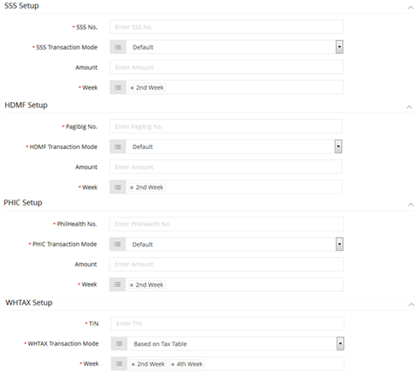

Figure 5. Employee Payroll Setup details

### Loans Entry

This is where one can create and review defined employees’ loans and their corresponding payments.

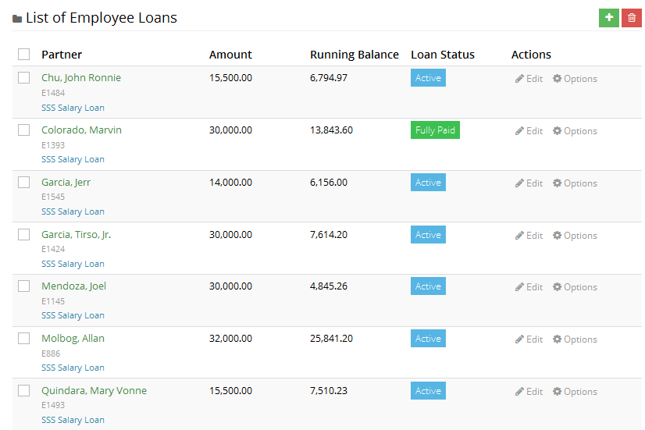

Figure 6. List of employee loans

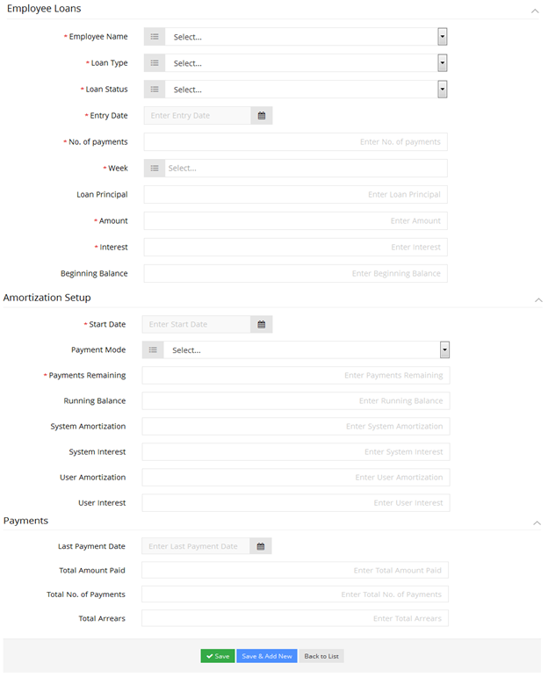

Figure 7. Employee Loan details

### Timekeeping Summary

This is where one can view summary of employees’ time records in specific pay periods.

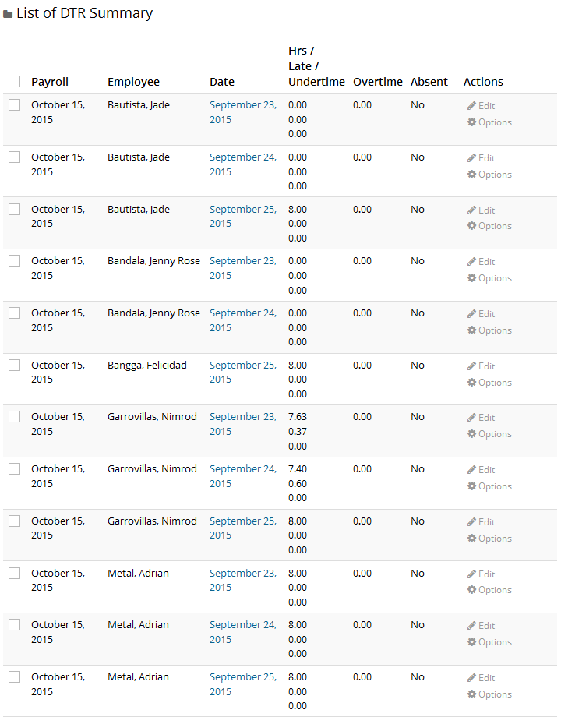

Figure 8. List of timekeeping period summary

## Listing and Applications

### Recurring Entries

This is where one can set up transactions with specific amount either added or deducted on a defined period of time.

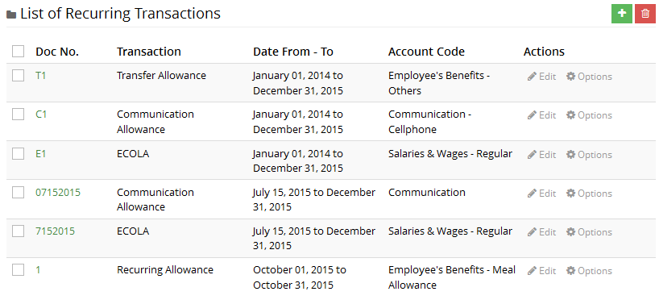

Table4. List of recurring entries

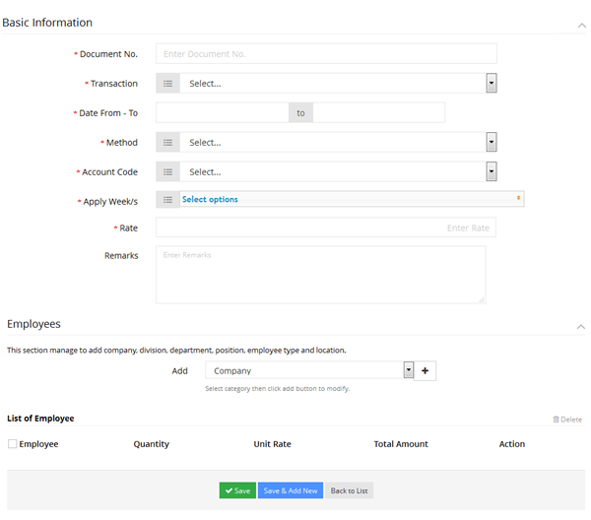

Figure 9. Recurring Entries details

### Batch Entries

This is where one can set up transactions in groups which are either added or deducted to employee’s wage on a specific payroll date only.

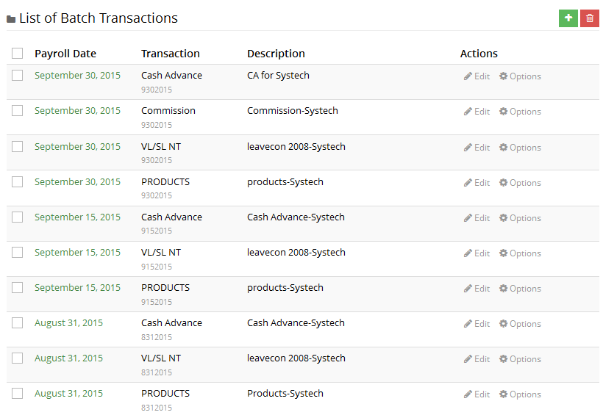

Figure 10. List of batch entries

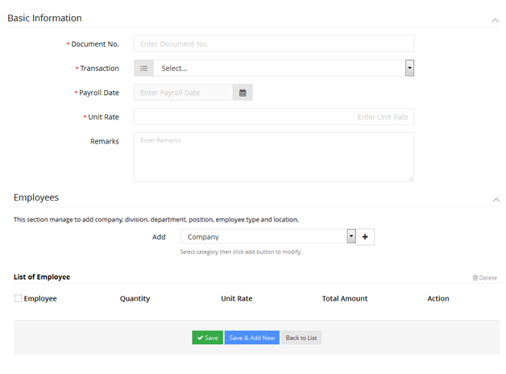

Figure 11. Batch Entries details

### Bonus

This is where one can set up employees’ bonuses.

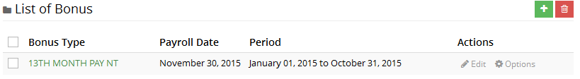

Figure 12. List of bonuses

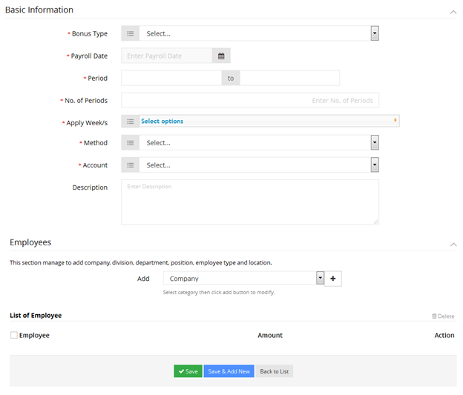

Figure 13. Bonus details

### Payroll Transactions

This is where one can access detailed payroll transactions per pay period.

#### Current Transactions

Refers to currently opened transactions in a specific pay period which may be edited as deemed necessary.

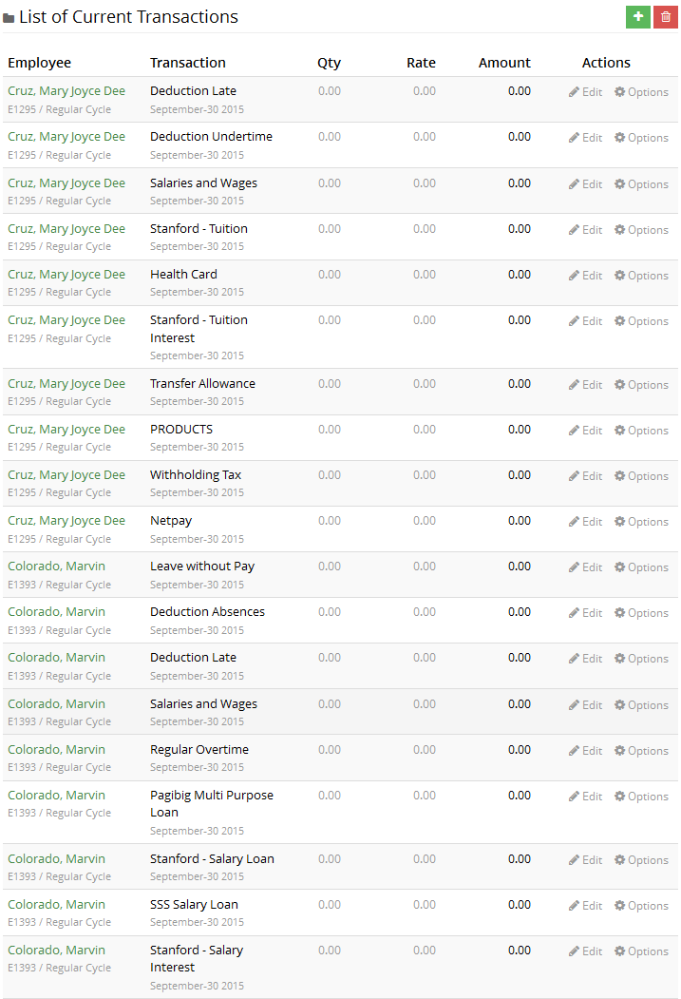

Figure 14. List of current transactions

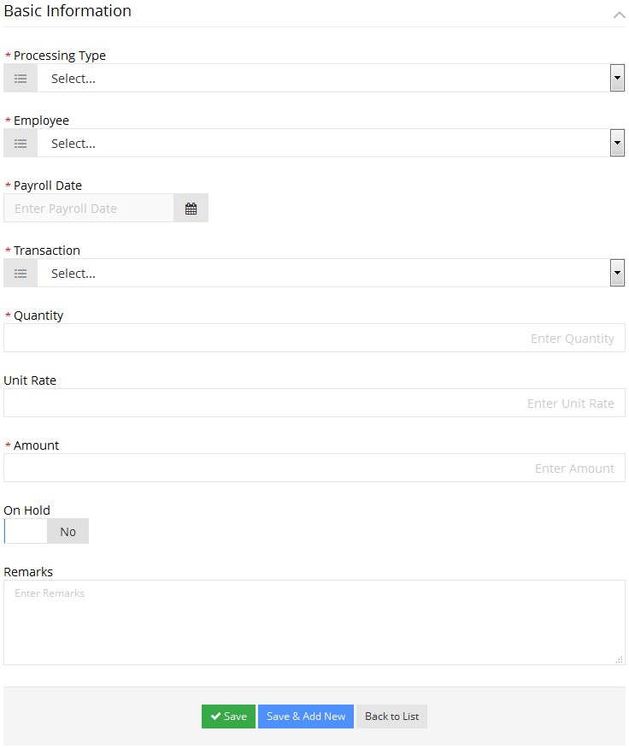

Figure 15. Current Transaction details

#### Closed Transactions

Refers to closed transactions in a specific pay period. Closed transactions cannot be edited.

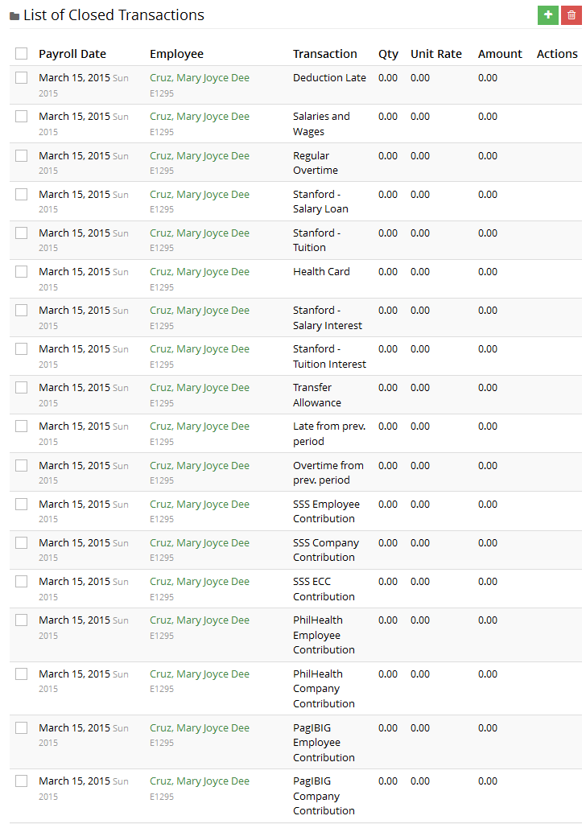

Figure 16. List of closed transactions

## Reports

As follows are the payroll reports already available in the system.

### Preliminary Report

This is the initial reference containing detailed transactions processed in a currently opened payroll period.

#### Summary

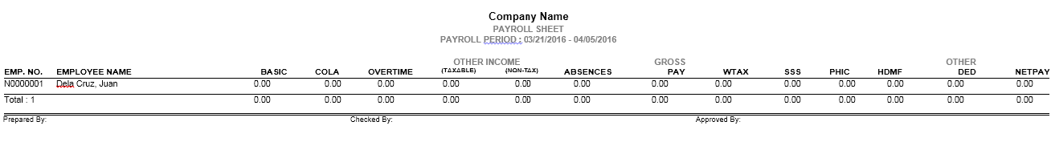

Figure 17. Preliminary Report

#### Summary of Earnings

This contains breakdown of employees’ processed earnings.

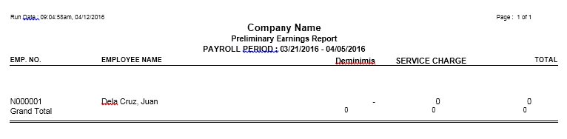

Figure 18. Preliminary Earnings Report

NOTE: Displayed earnings vary per transactions processed in a specific pay period.

#### Summary of Deductions

This contains breakdown of employees’ processed deductions.

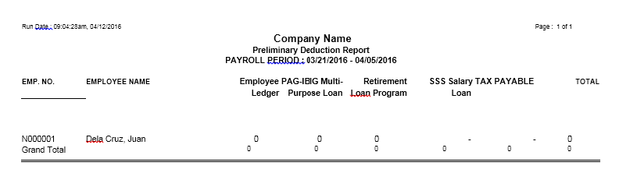

Figure 19. Preliminary Deduction Report

NOTE: Displayed deductions vary per transactions processed in a specific pay period.

### Payroll Register

This contains posted transactions processed in a specific pay period.

#### Summary

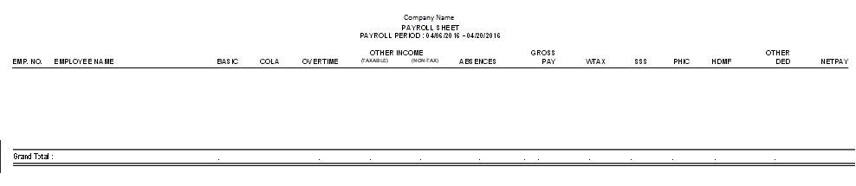

Figure 20. Payroll Register

#### Summary of Earnings

This contains breakdown of employees’ posted earnings.

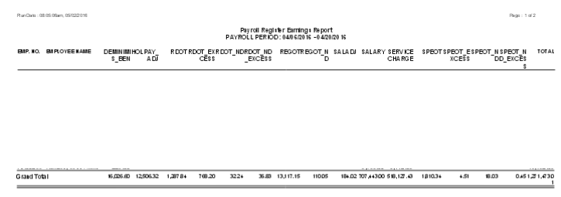

Figure 21. Payroll Register Earnings Report

NOTE: Displayed earnings vary per transactions processed in a specific pay period.

#### Summary of Deductions

This contains breakdown of employees’ posted deductions.

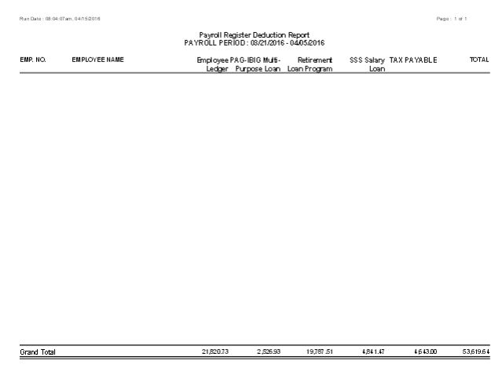

Figure 22. Payroll Register Deduction Report

NOTE: Displayed deductions vary per transactions processed in a specific pay period.

### Payslip

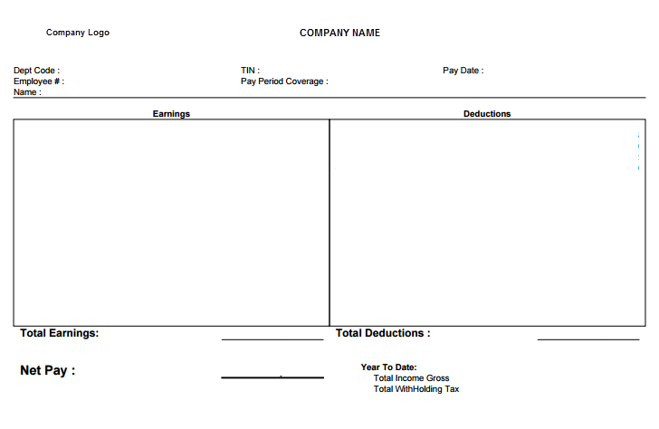

Figure 23. Payslip

### Government Reports

#### BIR 2316

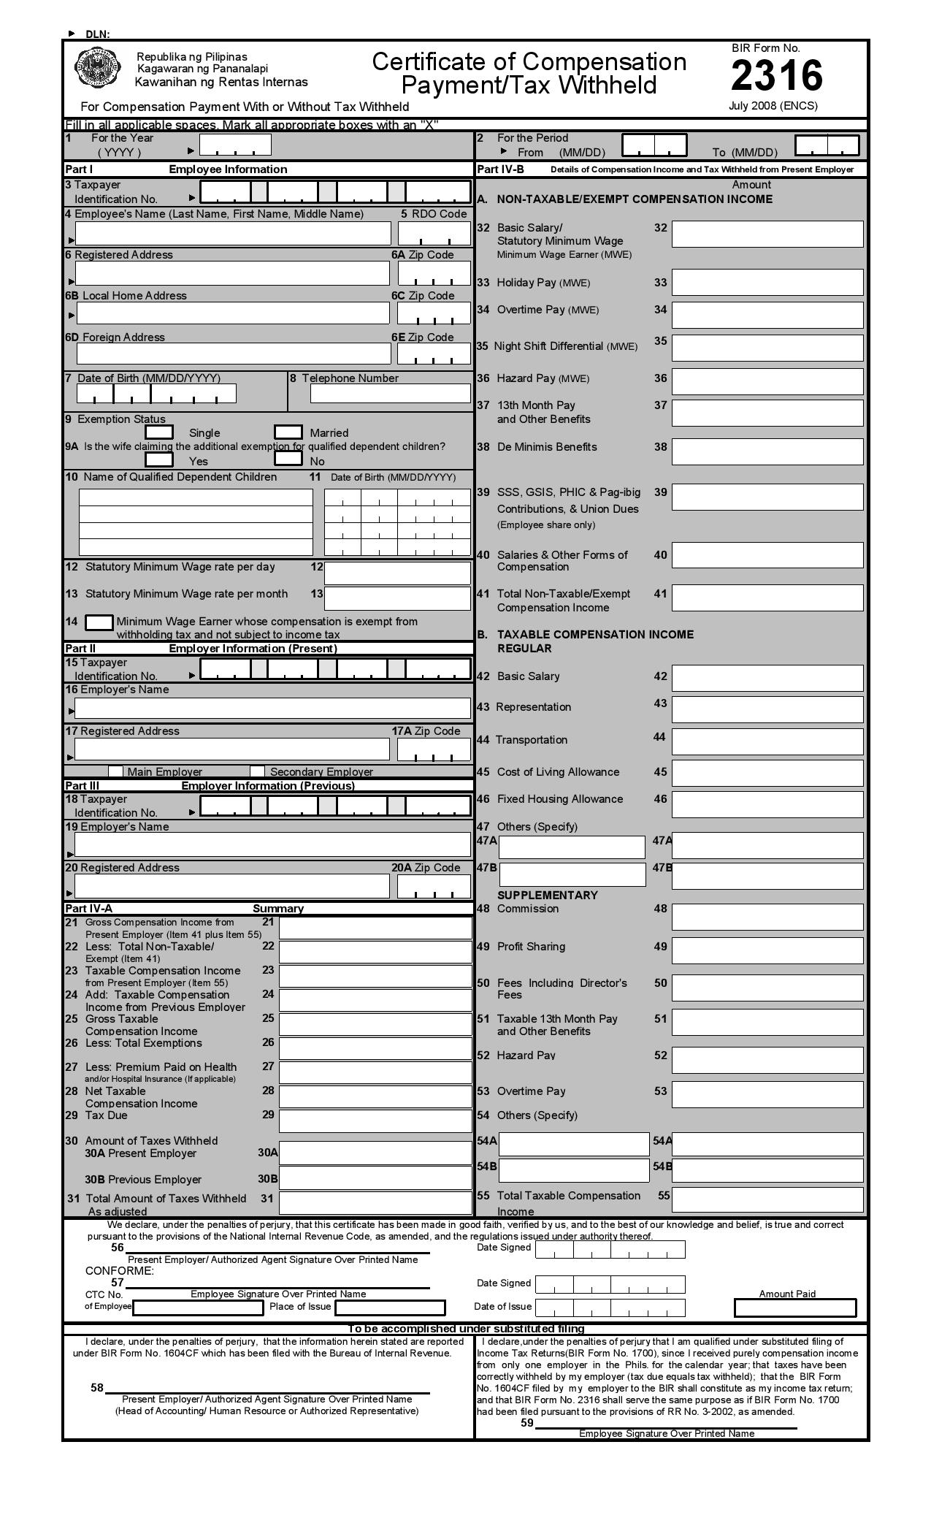

Figure 24. BIR 2316

#### SSS R-3 Monthly Premium Contribution

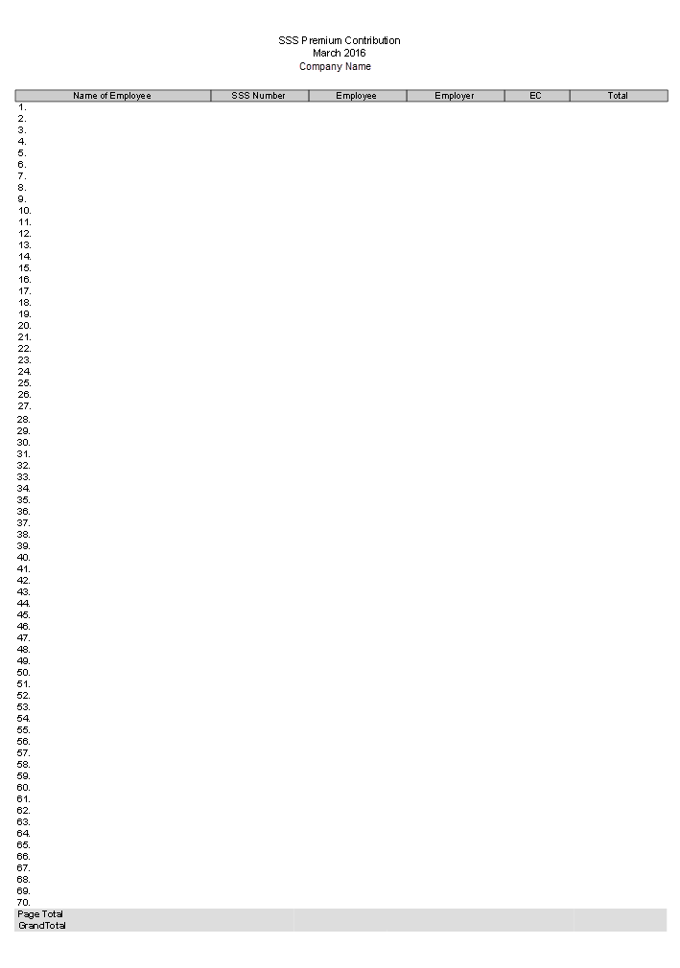

Figure 25. SSS R-3 Monthly Premium Contribution

#### SSS R-3 Quarterly Contribution Collection List

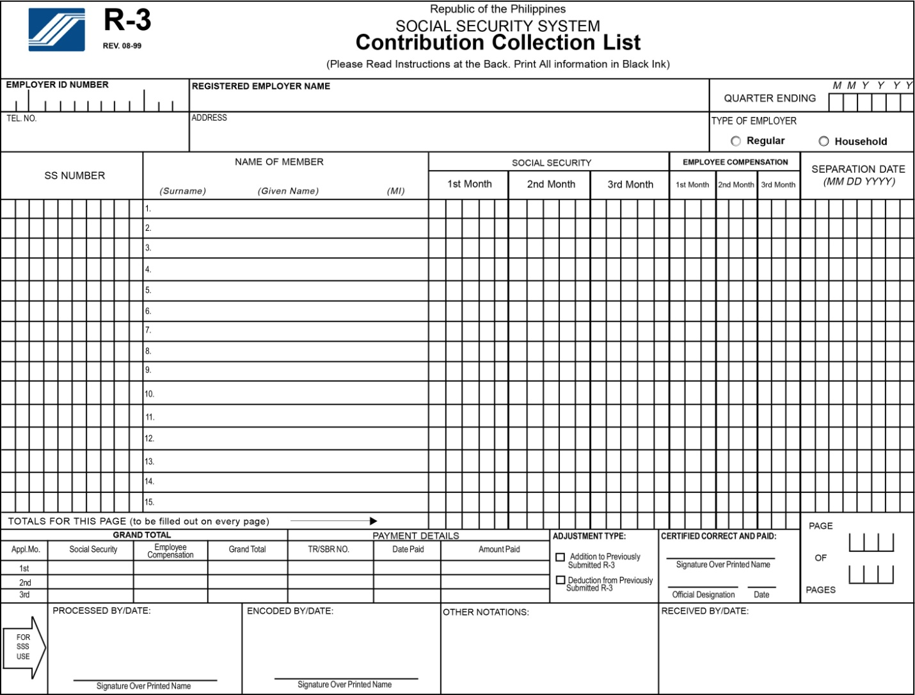

Figure 26. SSS R-3 Quarterly Contribution

#### SSS Remittance Certificate

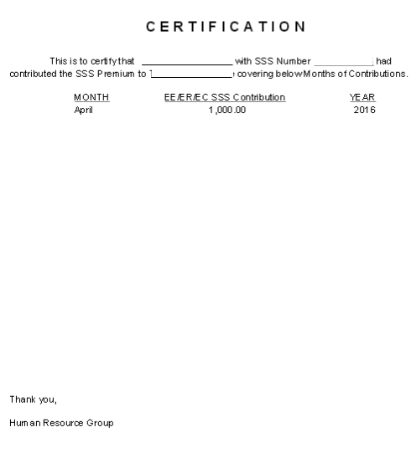

Figure 27. SSS Remittance Certificate

#### HDMF Membership Registration/Remittance Form

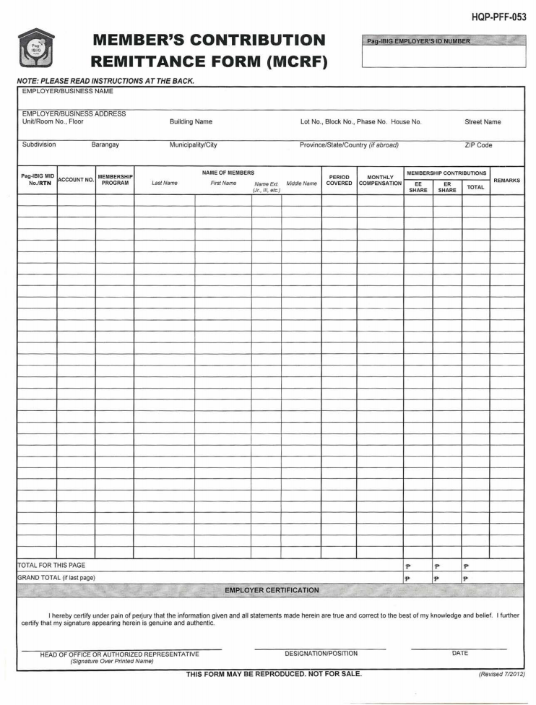

Figure 28. HDMF Membership Registration/Remittance Form

#### HDMF Quarterly Membership Registration/Remittance Form

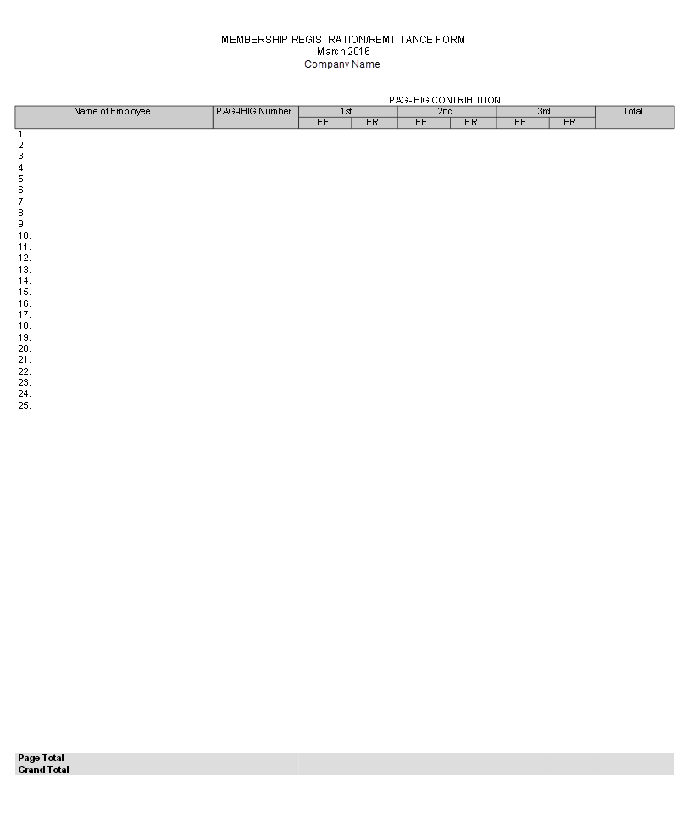

Figure 29. HDMF Quarterly Membership Registration/Remittance Form

#### HDMF Short-Term Loan Remittance Form (STLRF)

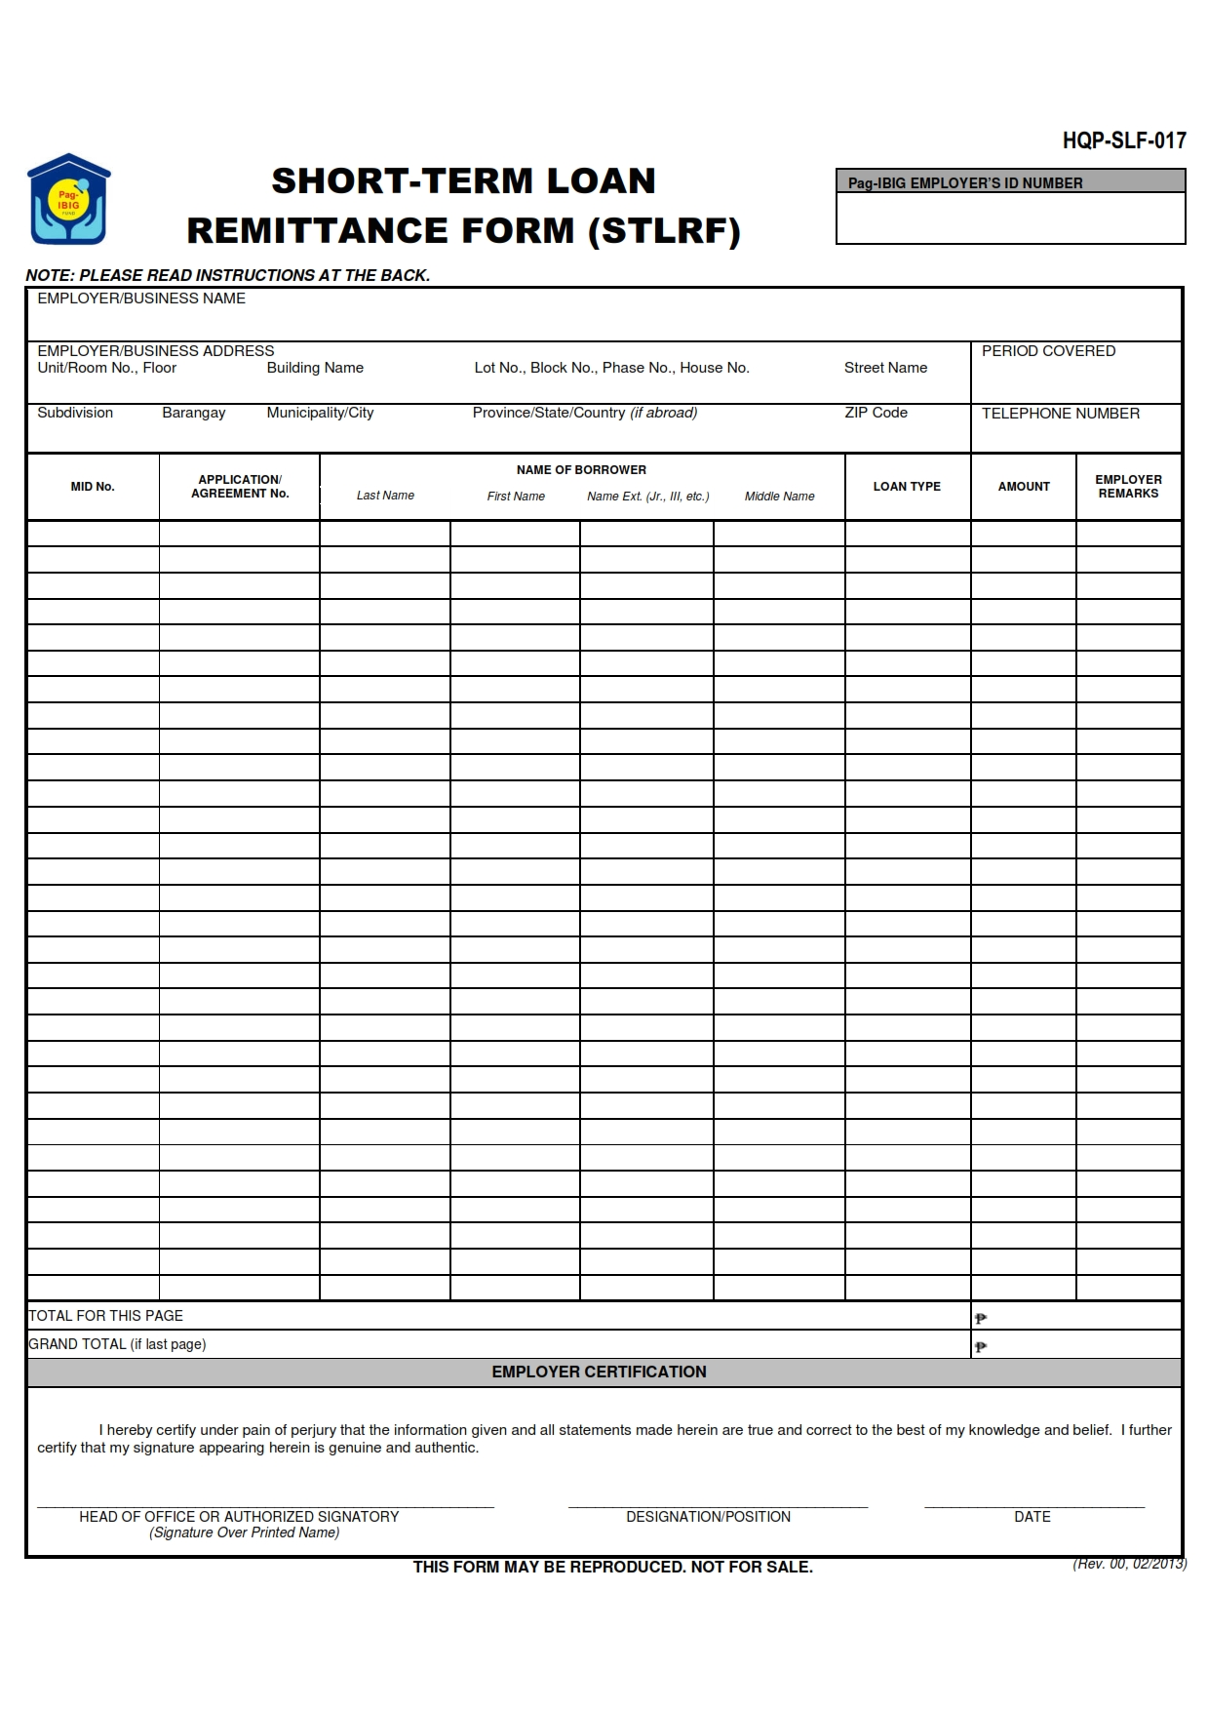

Figure 30. HDMF Short-Term Loan Remittance Form (STLRF)

#### HDMF Remittance Certificate



Figure 31. HDMF Remittance Certificate

#### PhilHealth RF-1 Monthly Employer’s Remittance Report

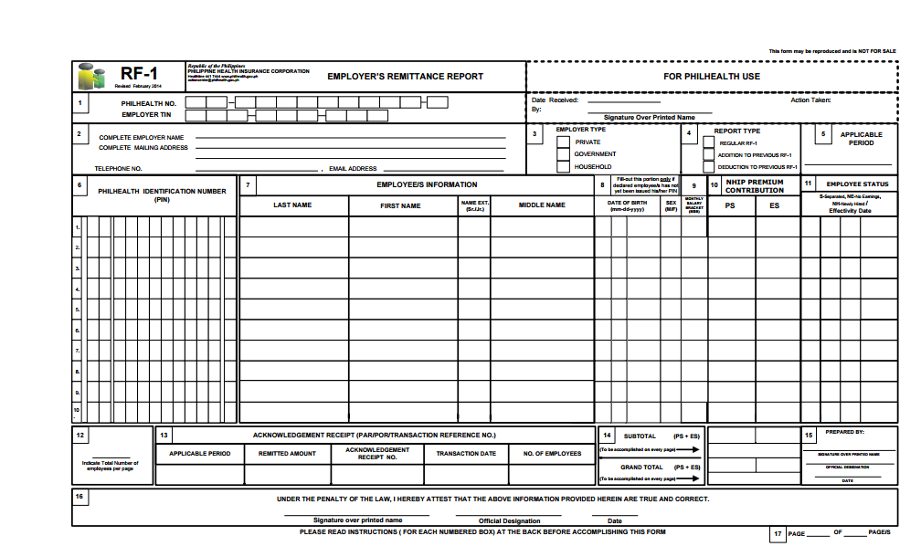

Figure 32. PhilHealth RF-1 Monthly Employer's Remittance Report

#### PhilHealth RF-1 Quarterly Employer’s Remittance Report

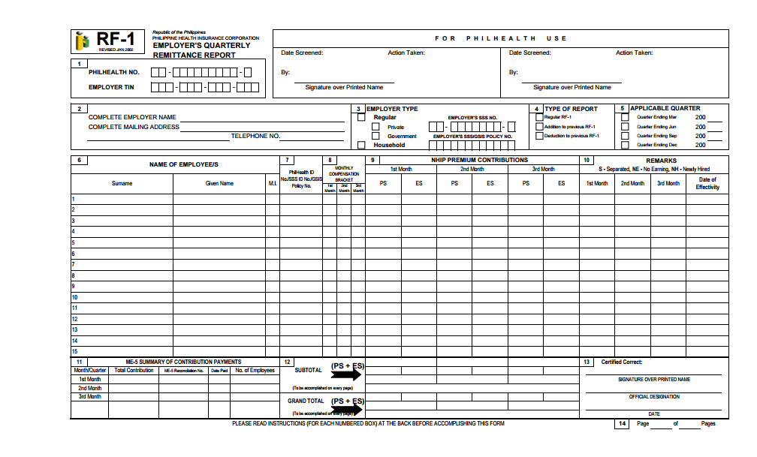

Figure 33. PhilHealth RF-1 Quarterly Employer's Remittance Report

#### PhilHealth Remittance Certificate

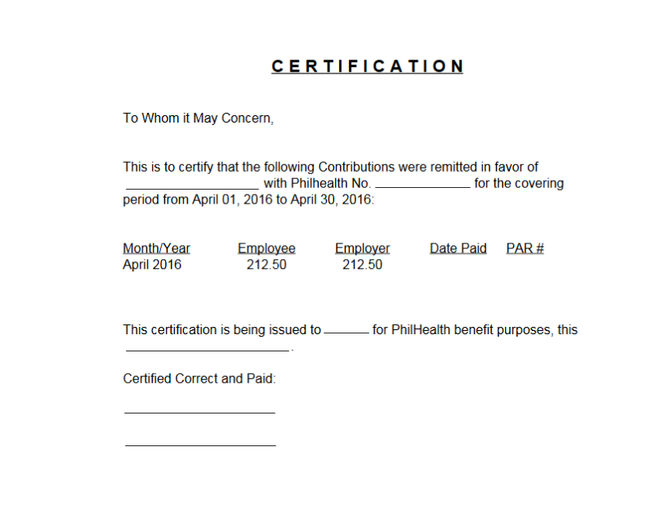

Figure 34. PhilHealth Remittance Certificate

#### ATM Register Report

This contains a list of employees with ATM.

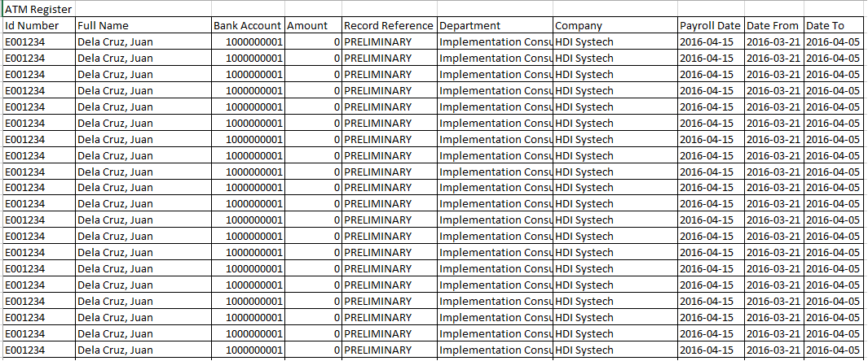

Figure 35. ATM Register Report

#### Non-ATM Register Report

This contains summary of all employees whose payment type is set to Cash.

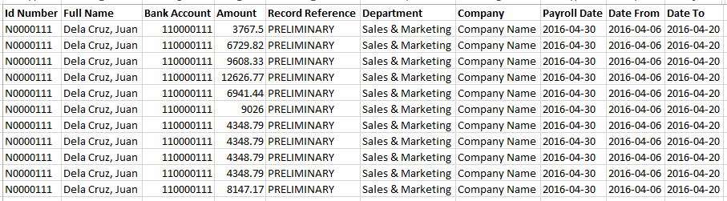

Figure 36. Non-ATM Register Report

#### Attendance Adjustment Report

This contains a list of payroll adjustment due to late approved timekeeping forms.

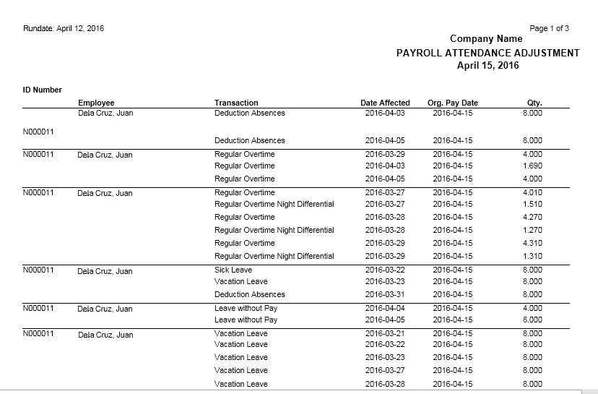

Figure 37. Attendance Adjustment Report

#### Deduction Schedule Detail Report

This contains a summary of all deductions of employees in a specific payroll date.

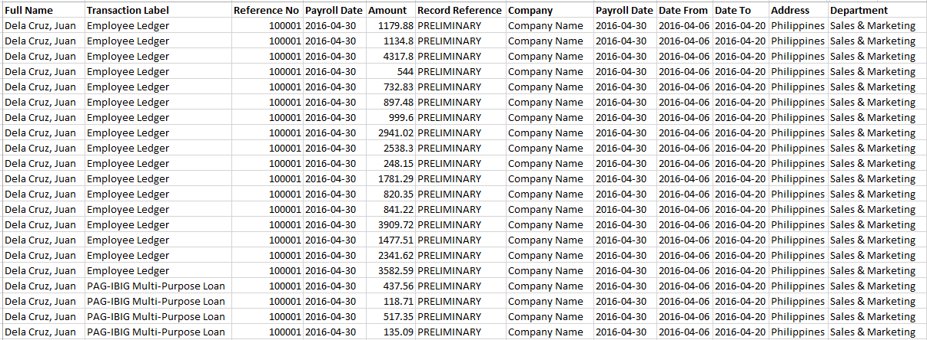

Figure 38. Deduction Schedule Detail Report

#### Journal Voucher

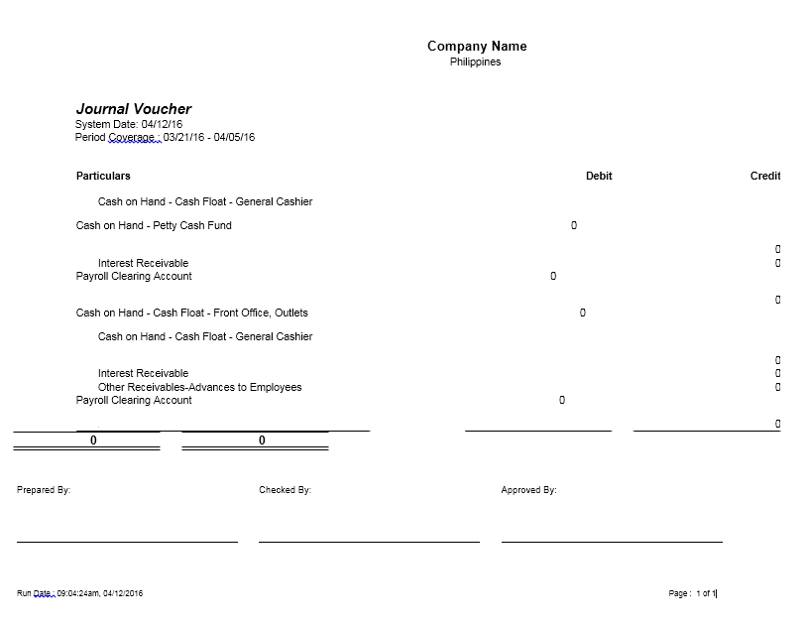

Figure 39. Journal Voucher

## 13th Month Pay

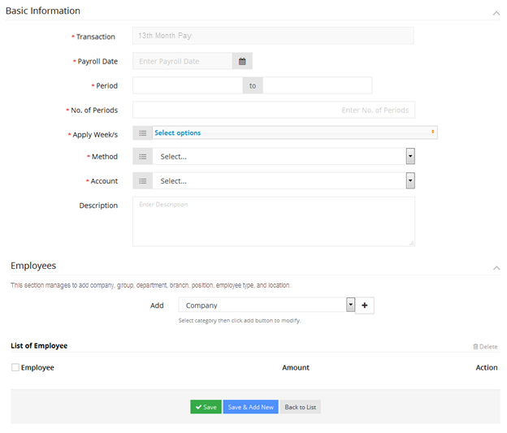

Figure 40. 13th Month Pay details

## Custom Reports

### Payroll Summary per Department

### Bank Remittance Text file

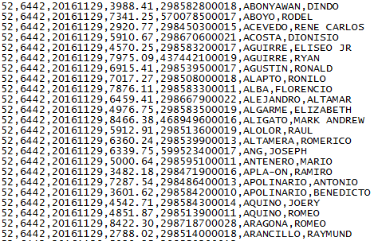

Figure 43. Bank Remittance Text File

# Signatories

This document has been approved as the Functional Requirements Specification for Payroll module.

|  |  |  |
| --- | --- | --- |
| **Prepared By:** | **Signature:** | **Date:** |
| Christi Ann Almario  *Project Manager*  Teemworx Inc. |  |  |

|  |  |  |
| --- | --- | --- |
| **Accepted By:** | **Signature:** | **Date:** |
| John Mahistrado  *Systems Development Manager*  Teemworx Inc. |  |  |

|  |  |  |
| --- | --- | --- |
| **Approved By:** | **Signature:** | **Date:** |
| Joel Mendoza  *Director*  Teemworx Inc. |  |  |

|  |  |  |
| --- | --- | --- |
| **Approved By:** | **Signature:** | **Date:** |
| Rommel Ardena  *Section Manager*  Victorias Milling Company, Inc. |  |  |
| Sheila Cabrestante  *Division Head*  Victorias Milling Company, Inc. |  |  |
| Teresita Ilagan  *Chief Finance Officer*  Victorias Milling Company, Inc. |  |  |